MND Gas Storage auction application

User Manual

An internet application intended for management of auction cases: sale of gas, sale of storage capacities in gas storages. The application does not require any physical installation at any party involved in the auction process. The application administrator provides remote access to the solution through a web interface. The application is accessible 24/7 with 99.9% annual availability.

Nar marketing, s.r.o.

May 2009

The auction application is available at: http://mndgs.proe.biz. Newcomers as well as ordinary applicants can access the auction application through www.gasstorage.cz website.

Auction application’s homepage
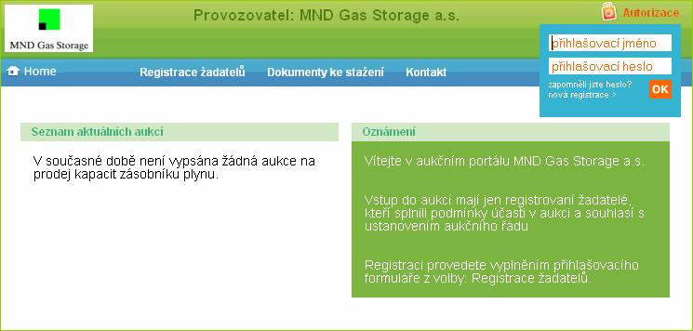

Application’s homepage

An unregistered visitor of the auction application can view currently published auctions on the portal homepage: List of current auctions (left information block). If no auction is published, the portal displays information that no auction is currently taking place.
The left block displays current Announcements for the visitors and in particular the information about the method of login to individual auctions.

First item of the application menu is Home for return to the homepage.

Registration is the next item; here, the “applicants” can fill-in the registration form and thus obtain access into the “non-public” section. In this section, the applicants register to individual auctions, submit their offers (administer the auctions) and manage their registration data.

Downloads – this item contains publicly available documents, for example the auction rules, specimen agreement, and/or other important documents required for the auction application operation. These documents are available for reading and for download.

Contact comprises the identification data of the administrator and enables communication with the person appointed by the administrator.

List of current auctions

The list displays all current auctions regarding sale of capacities in underground gas storages. Clicking the left mouse button on the selected auction’s line displays given auction with schedule on the left and Invitation on the right.
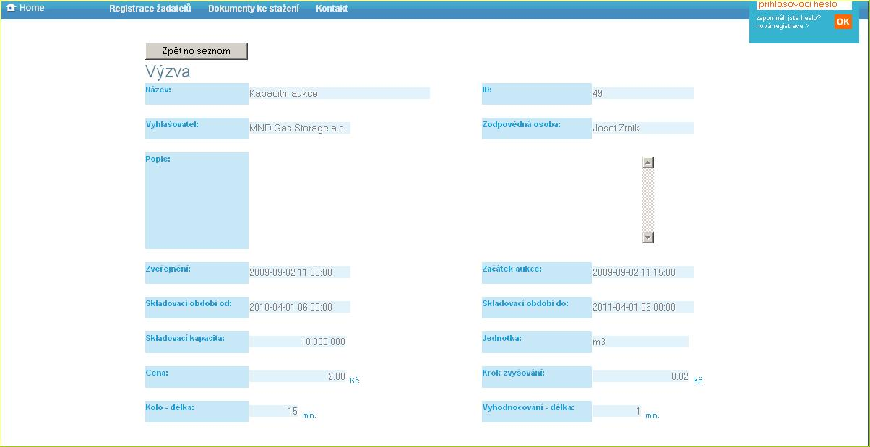

The Attachments sub-menu contains complete documentation for the auction available for download. The Application sub-menu is inactive. Clicking on it displays a request for registration and login details authorization for access to applicant’s personalized interface.
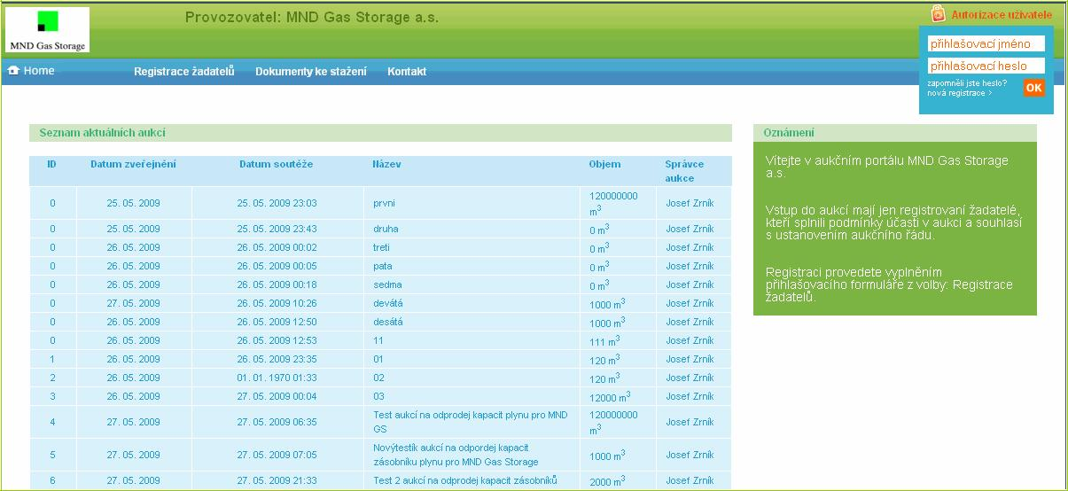

List of auctions

Registration

Each new applicant is asked whether they are a natural person or legal entity. Based on that, corresponding form is displayed to the applicant, which has to be filled-in truly and completely. At the end, the applicant selects their login details (user name and password) and submits the form.

Registration – legal entity
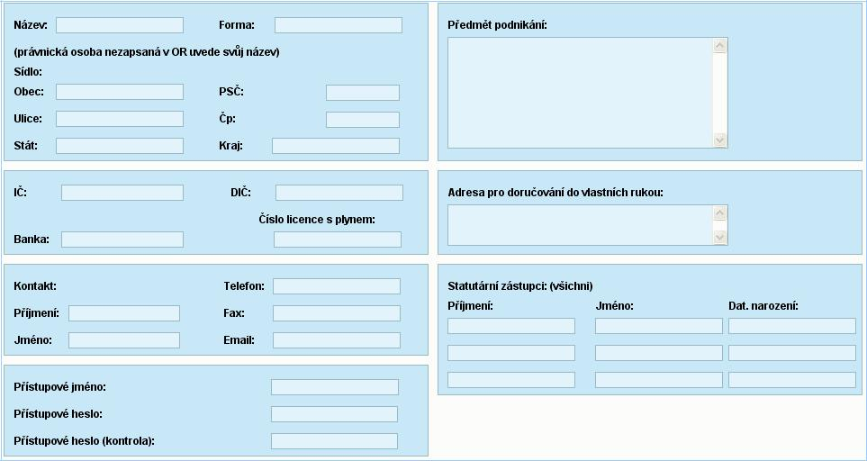

Registration – natural person
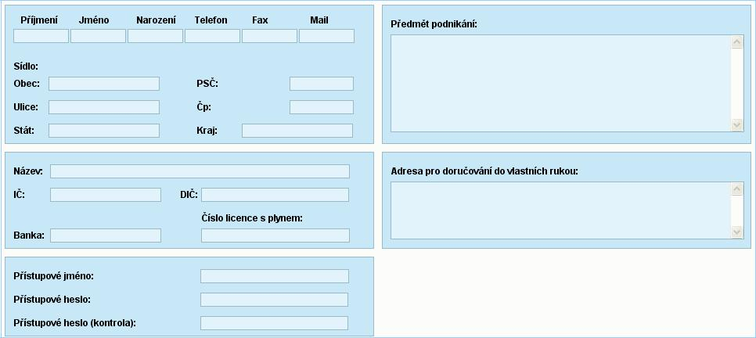

After successful registration, it is possible to log into the administration interface by entering the login details into the authorization box (right corner on the homepage). In case of lost login details, the user must contact the administrator.

Personalized interface for authorized users
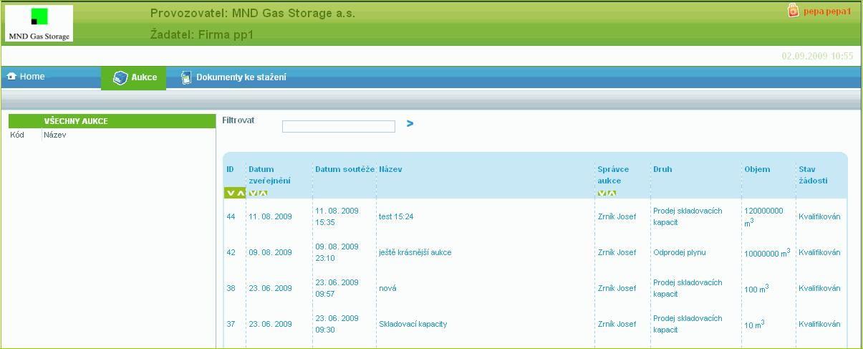

Authorized user

Once the user enters their own (private) space, they can see the list of all current auctions. They can view the auction, join them, or they do not have to respond at all, thus refusing to participate. (Newly added sub-item Auctions is open.) The last column of the auctions list contains information about the status of each individual auction: not joined/joined/not qualified/qualified (capacity auctions) respectively. Additionally, invitation/rejected (for auctions regarding gas sale). Current auctions with active participation of the applicant are highlighted with red (bold).

Clicking on the auction line opens the auction and displays the Invitation (similarly to anonymous visitor of the portal), however, the part Application is already active. There is also an option Auction hall which remains inactive until the qualification. The following notice is displayed: “Your qualification is pending, the Auction hall is inaccessible“.

Application
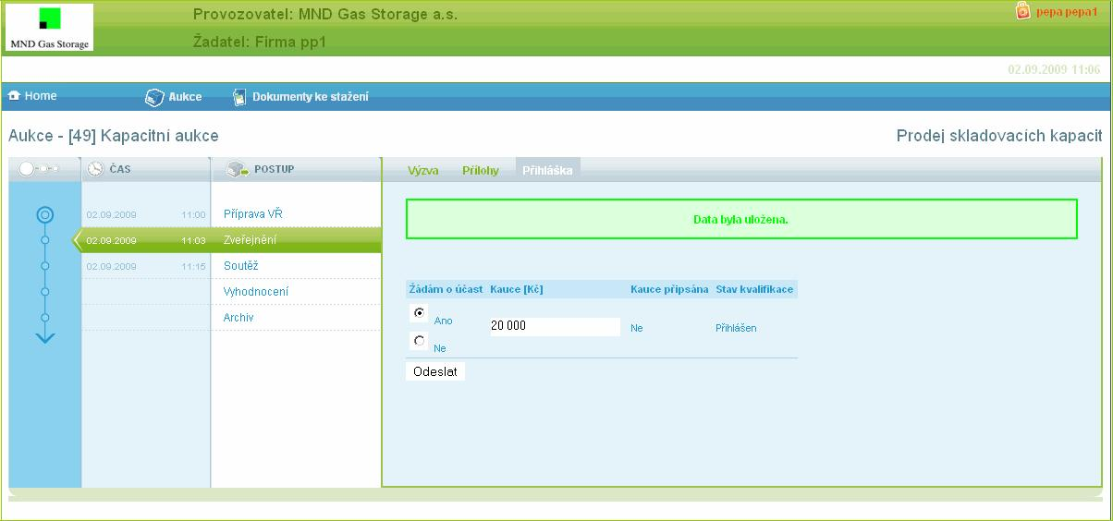

When Application is selected, a table for applicant’s progress recording

is displayed. The first column is intended for the applicant to join the auction.

Second column: Proposed deposit that they intend to submit. These two columns are completed by the applicant. The third column contains a confirmation of deposit payment to the bank account of the auction organizer. The fourth column is used by the auction organizer for confirmation or rejection of the applicant’s qualification. (Columns 3 and 4 are completed by the administrator).

Auction hall
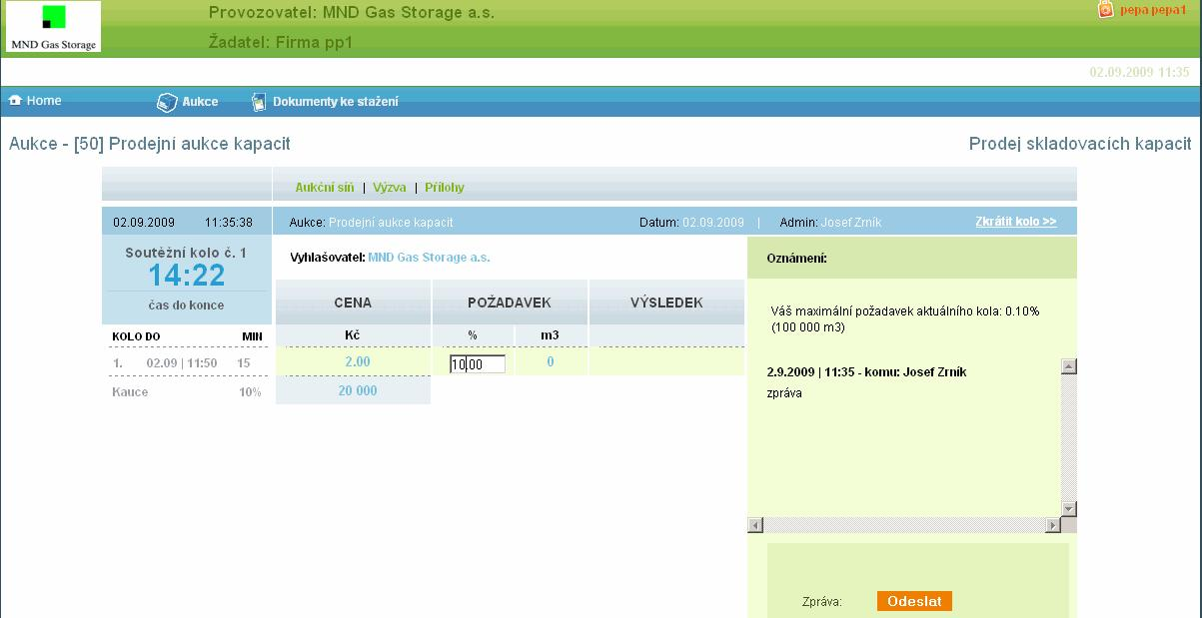
The qualified applicant may view the auction hall as soon as he meets the qualification requirements (this usually takes place before the auction) so he usually sees an inactive auction hall (it is not possible to make any offers) with countdown until the beginning of the auction.

Auction hall during auction – submission of offers

At the beginning of the auction, the auction hall window is refreshed and another sub-item appears in the sub-menu: Evaluation. In column: Request, the applicant may enter their request (up to the amount of the deposit or value input during the previous round – this information appears in the chat at the very beginning of the particular auction round. The applicant sees the time until the end of the round and they must submit their offer before this deadline otherwise they end in the auction.

Request for round shortening

The applicant may apply for round shortening immediately after request specification. If all applicants do so, the administrator may shorten the round and speed-up the auction. The rounds are shortened to complete minutes.

Intermediate round

There is a pause between individual rounds due to the evaluation of each round and also for the event of server outage or administrator’s connection failure. The auction is backed-up to a second server so it can switch to the backup server in case of primary server’s failure.

Switching over to the second server requires certain time (the applicants must again log into the auction!).

Evaluation

If the auction conditions are satisfied, i.e., the interest in the product offered in the auction at given price decreases below 100% of the offer, the auction is completed and transferred into the booking status. Reservation is awarded to the applicant that applied in the last (or second-to-last) round. Results overview (auction report) is available under Evaluation and can be printed out by the applicant.

Administration interface of the operator – auction administrator
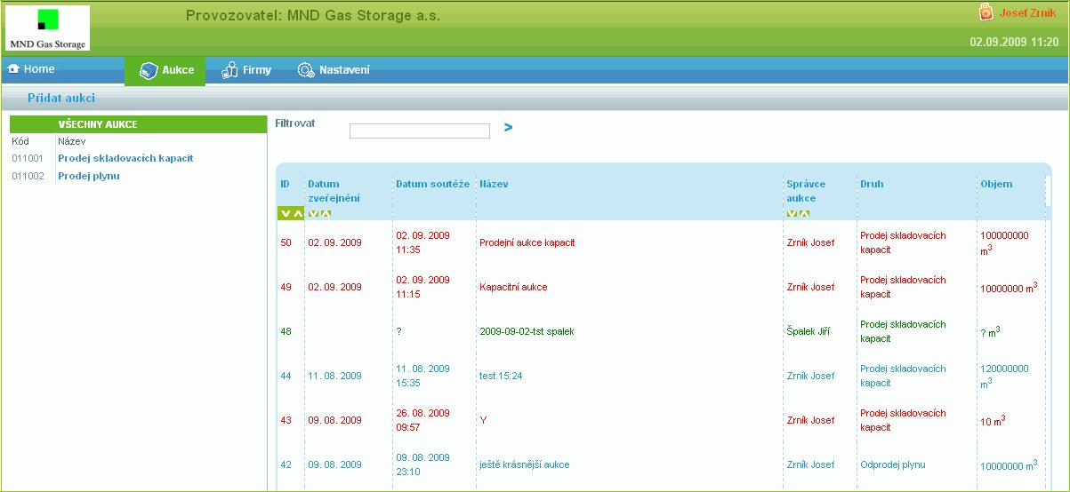

Administration interface of the application operator

Once the system operator is authorized, an administration environment for auctions management displays. This environment contains an open list of all auctions. The left column offers two categories of auctions:

- sale of gas storage capacities

- gas sale

Clicking on the category displays only the auctions for given auction category (filter). The administrator can view the list, sort it, organize the items, and enter an auction by clicking on its line.

In addition to the open list of Auctions, the administrator can use Home item to return to the homepage, view the list of registered applicants by clicking on Companies, administer the operator’s representatives in Settings, and administer any information and documents intended for the applicants.

Creating auctions

The main item Auction contains a sub-item Add auction. After clicking on this item, the auction administrator is prompted to complete a new auction card (name, classification, description).
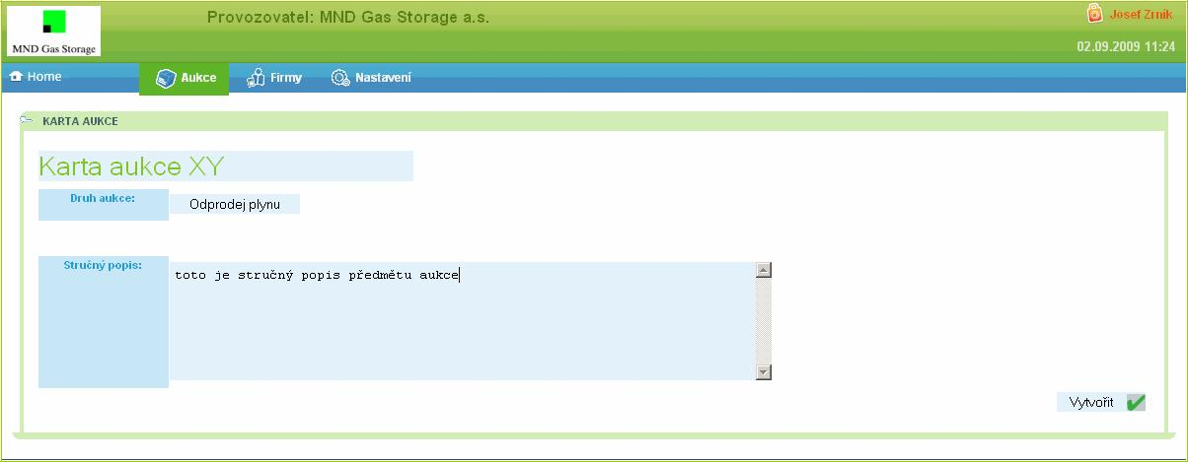

Auction card

After this data is saved, a screen for auction conditions definition appears automatically

– invitation (course of the auction and definition of basic parameters), attachments (contractual conditions) and the possibility of automatic or manual auction publishing. When an auction regarding Gas sale is defined, it is also possible to select auction participants (Applicants).
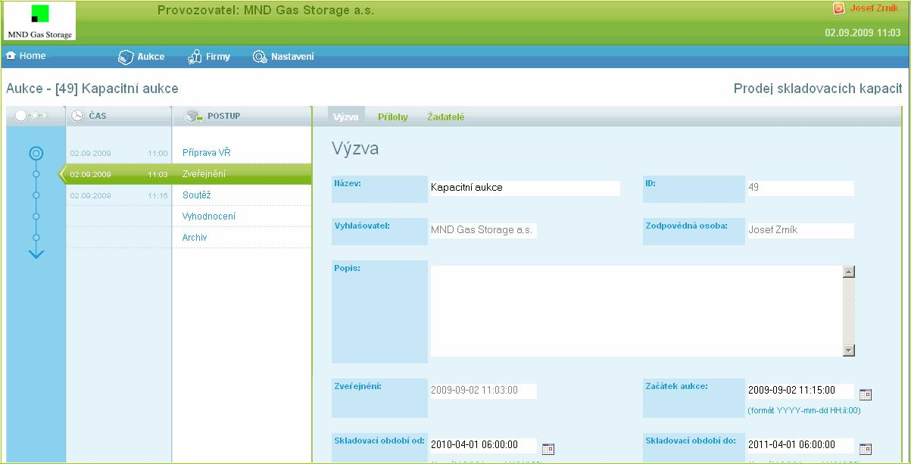

Environment for auctions management – preparation, establishment

Auction publishing

Capacity auction – automated process – publishing definition is specified in basic

parameters. The auction is published on the portal’s homepage with link to the website of MND.

Gas sale – individual item, auctions are not published on the title page and/or on MND’s website. The participants (applicants) are approached directly by an e-mail sent to their address at the moment of publishing time activation.

Login of applicants
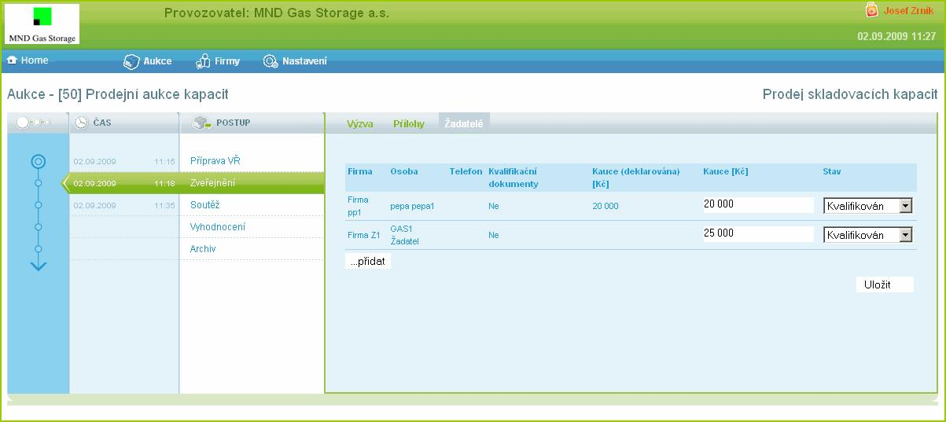

Under applicants, the auction administrator can watch the login status of individual companies:

- Logged-in – applied for the auction and declared (optional) the auction volume

- Qualified – applied, qualification documents and deposit were received before the specified deadline

- Not qualified – failed to meet the conditions of the auction - rejected

Auction

Auction starts at the time specified in the invitation. Qualified applicants may submit requests during the auction round. These requests are displayed to the administrator on-line in the administrator’s view of the auction hall. If the applicants apply for round shortening, the administrator receives relevant information (the applicant is highlighted) about this request. If the request is confirmed by all participants, the administrator may shorten the particular auction round. Chat communication with the participants is possible during the entire term of the contest. The applicants only communicate with the administrators. They do not see the communication between the administrator and other users.
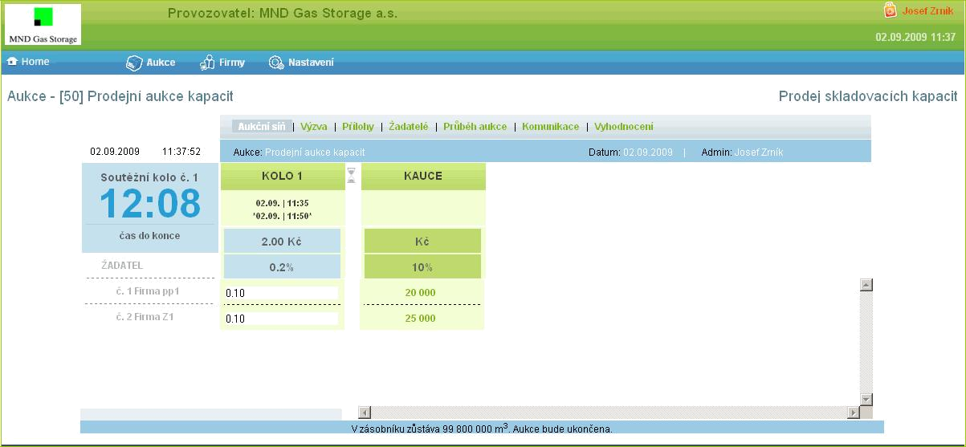

Intermediate round

Evaluation follows after auction round completion. “Evaluation” intermediate round is intended for this purpose. In this round, individual requests are analyzed and data is copied to the backup server for the event of main system failure.

New auction round

Another round takes place if the sum of the requests exceeds 100% of the offer. The new round differs from the previous one only by new unit price of the subject of the auction. The applicants may again respond to changed conditions similarly to the previous round. The applicants are sorted in the hall according to the amount of their request. The applicants who did not submit their request in the previous round are sorted under the group of active users.

Booking

The auction ends when the requests are equal or lower than 100% of the offer. Requests from the last round are booked for individual active applicants. Booking from the previous round is then calculated for the difference up to 100% (see the auction rules). Reservation is awarded only to the applicant that applied in the last (or second-to-last) auction round!
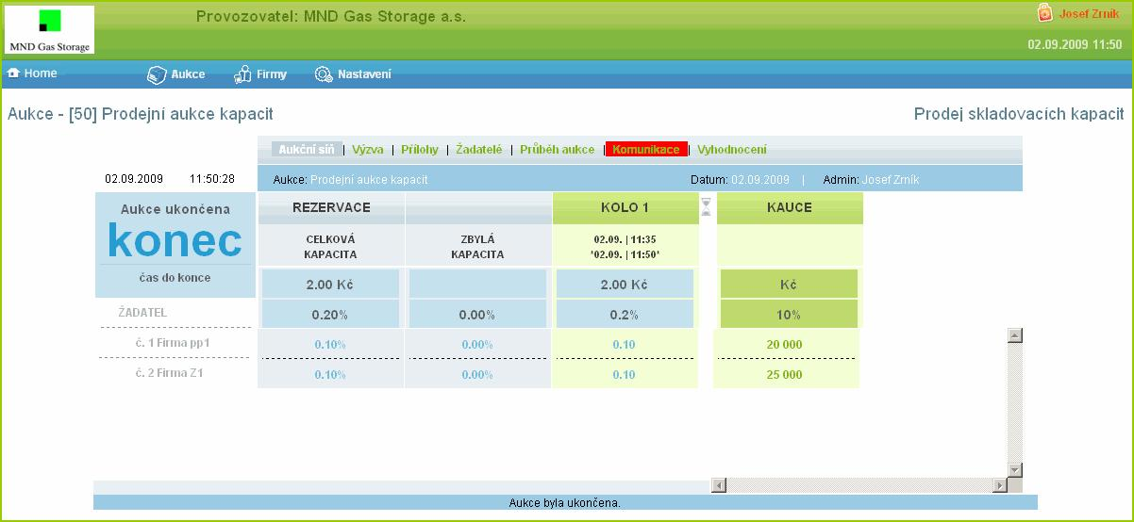

Evaluation

Auction evaluation (forecast) can be prepared in any phase of the auction. Upon auction end, the process switches over to the evaluation and the operator can print final auction report.

Preliminary results
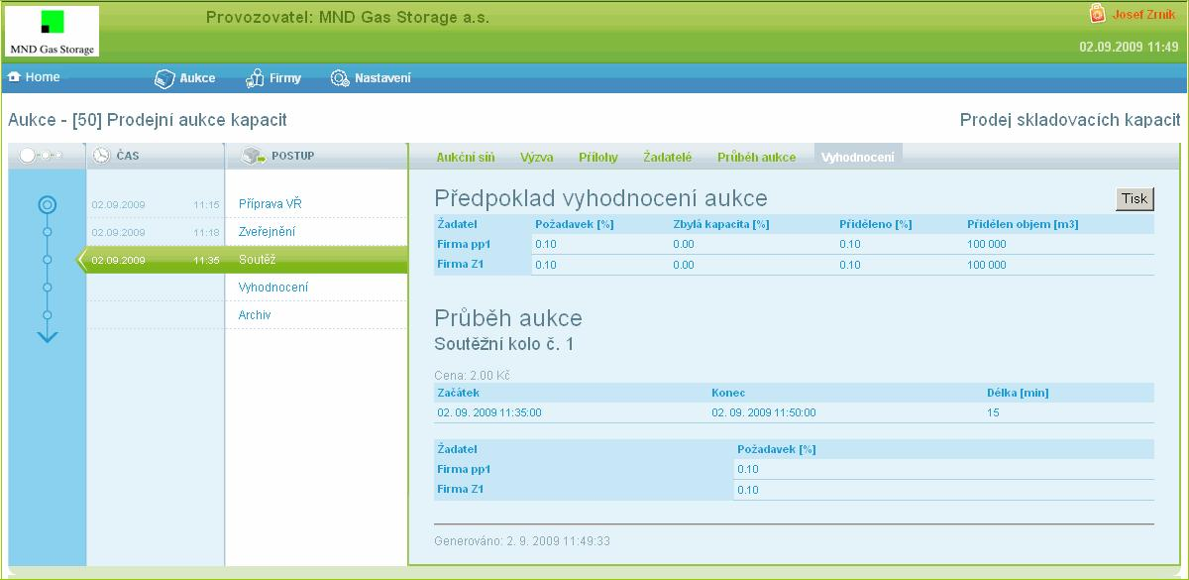

Final evaluation of the auction
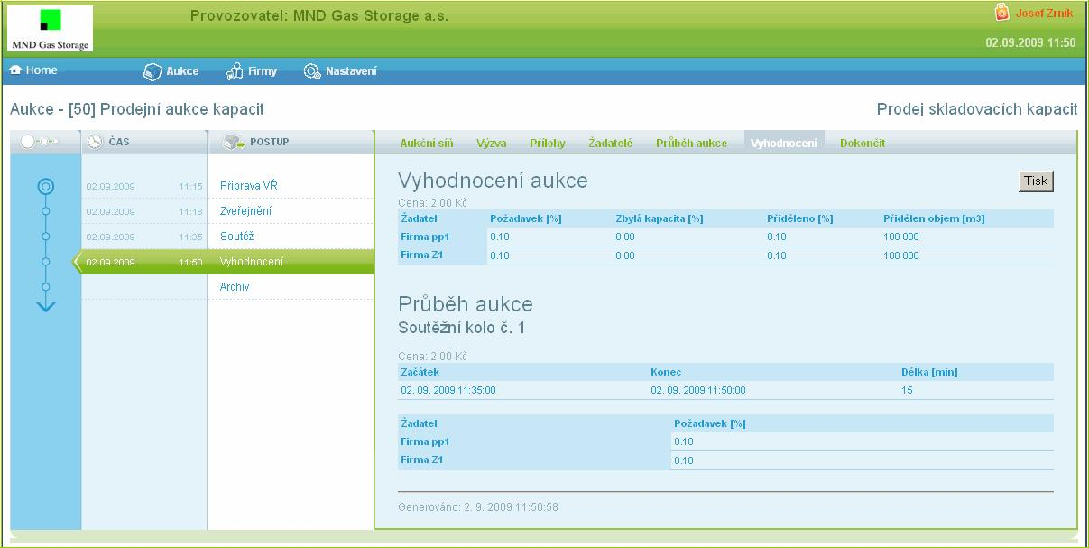

Completed auction is a prompt for the active applicants to print their report and confirm their interest by signing the agreement. Completed contest changes its status (activated by the administrator) to archived and the entire business case is closed.

Settings

A new sub-menu appears when this option is selected:
Users: for managing the operator’s personnel,

Documents for download: for management of information and documents intended for applicants,
System settings: here the administrator can specify whether the information about current auctions will be displayed on the homepage and whether it is possible to log-in – register (new applicants – companies)
